**Anik Shaikh**

**Enrolment no – 23162121021**

**Batch 31**

**OOP**

**Practical 2**

**Q – 1 Typecasting  and operators**

* : Convert an amount from one currency to another using given exchange rates.
* : double for currency amounts, String for currency codes.
* : Arithmetic operators for conversion calculations.

Code:

import *java*.*util*.*\**;

*class* CurrencyConverter {

*public* *static* void *main*(String[] args) {

        Scanner sc = *new* *Scanner*(System.*in*);

        double amount;

        System.*out*.*println*("Enter the amount in INR: ");

        amount = sc.*nextDouble*();

        double exchangeRateUSD = 82;

        double exchangeRateEUR = 120;

        double usdAmount = amount / exchangeRateUSD;

        double eurAmount = amount / exchangeRateEUR;

        System.*out*.*println*("The amount in INR is: " + amount);

        System.*out*.*println*("The amount in USD is: " + usdAmount);

        System.*out*.*println*("The amount in EUR is: " + eurAmount);

    }

}

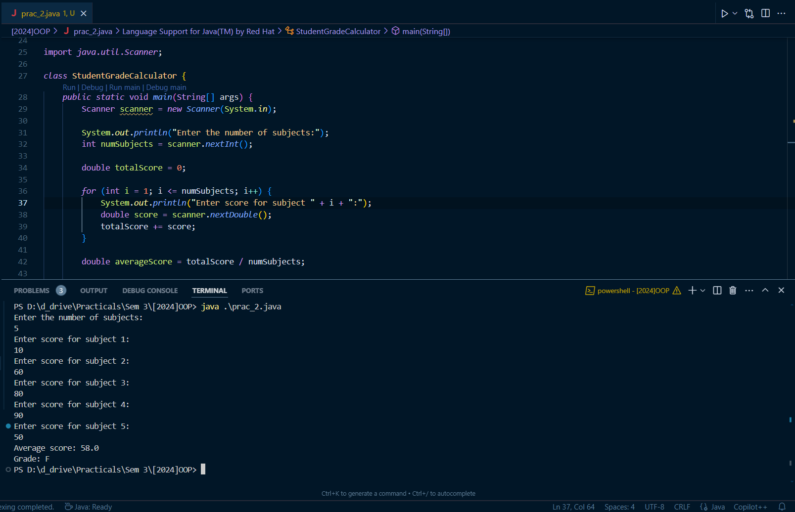

Q – 2

* : Calculate the average grade of a student based on their scores in different subjects.
* : int or double for scores, char for grade letter.
* : Arithmetic operators for calculating the average and conditional operators to assign grades.

Code:

import java.util.Scanner;

class StudentGradeCalculator {

public static void main(String[] args) {

Scanner scanner = new Scanner(System.in);

System.out.print("Enter the number of subjects:");

int numSubjects = scanner.nextInt();

double totalScore = 0;

for (int i = 1; i <= numSubjects; i++) {

System.out.print("Enter score for subject " + i + ":");

double score = scanner.nextDouble();

totalScore += score;

}

double averageScore = totalScore / numSubjects;

char grade;

if (averageScore >= 90) {

grade = 'A';

} else if (averageScore >= 80) {

grade = 'B';

} else if (averageScore >= 70) {

grade = 'C';

} else if (averageScore >= 60) {

grade = 'D';

} else {

grade = 'F';

}

System.out.println("Average score: " + averageScore);

System.out.println("Grade: " + grade);

scanner.close();

}

}

